SEASON

1995-96

ST ANDREWS CUB SCOUTS

MACCLESFIELD & CONGLETON DISTRICT CUB SCOUT LEAGUE

Home games played on Ryles Park School playing fields.

Games played Saturday AM.

Squad:

Alister Lewis Andrew Pirie James Viggers Darren Addison (F)
William Morrison, Billy Maddox Scott Blackburn David Scott
James Ralph Mathew Pritchard James Spooner Kieran Bamford
Simon Howarth

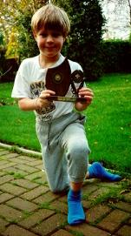
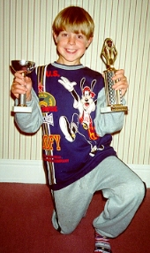

St Andrews 5 Henbury 3 (2)
Prestbury 1 St Andrews 1 (-)
Henbury 4 St Andrews 5 (4)
St Andrews 7 St Albans B 1 (3)
St Andrews 3 Dane Valley 7 (-)
Tytherington 1 St Andrews 4 (2)
St Andrews 5 Parish Church 1 (2)
St Andrews 2 St Pauls 2 (2)
St Johns 5 St Andrews 2 (2)
Sutton 4 St Andrews 1 ? (1) 30/9/95 Left at half time to be mascot PNE v Cheste. Daz goal low long range shot.r
St Andrews 10 Upton Priory 2 (4)
St Albans A 7 St Andrews 1 (1) Daz goal lob from half-way line (which may have gone over… not net)

Others Games? : Congleton,, 2nd Bollington, 15th Macc, Beech Lane,, Congleton, 1st Macc..... ???

League Table:

P W D L Pts
St Albans A 15 15 0 0 45
Beech Lane 15 11 3 1 36
Henbury 15 11 0 4 33
Sutton 15 9 3 3 30
Prestbury 15 8 2 5 26
St Andrews 15 8 1 6 25
-------------------------------------------------------------------------------------------------
St Johns 15 7 4 4 25
St Pauls 15 6 1 8 19
Congleton 14 5 3 6 18
Parish Church 14 5 1 8 16
Tytherington 15 4 4 7 16
Dane Valley 14 4 3 7 15
2nd Bollington 15 3 2 10 11
Upton Priory 15 3 2 10 11
15th Macclesfield 15 3 1 11 10
St Albans B 14 - - - -

AKELAS CUP 1996

St Albans A 5 4 1 0 13
Beech Lane 5 3 1 1 10
Prestbury 4 2 0 2 6
Sutton 4 2 0 2 6
St Andrews 5 1 0 4 3
Henbury 5 1 0 4 3

MACCLESFIELD & CONGLETON DISTRICT CUB SCOUT 5-A-SIDE CUP

Played at Macclesfield Leisure Centre.

Saturday 10th February 1996

Group: St Andrews 3 ???? 0 (?)
St Andrews 1 Sutton 4 (?)
St Andrews 1 Dane Valley 0 (?)

Qtr-Final?: St Andrews 1 Sutton 1 (1)

St Andrews lost on penalties

MACCLESFIELD & CONGLETON
CUB SCOUT REPRESENTATIVE MATCH

Selected as St Andrews ‘Player of the Season’

Played at Congleton Town FC Friday 12th April 1996 (Evening)


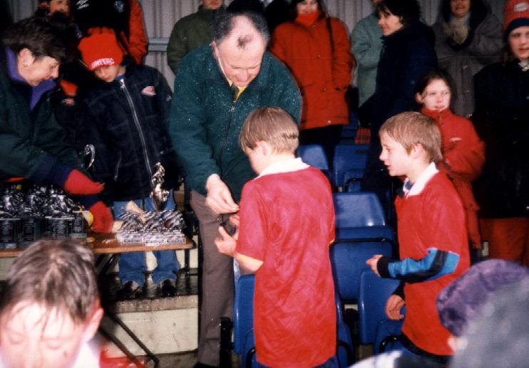
Played in heavy rain and sleet.

St Albans 3 The Cub League Representative 11 0

Gareth Ridge (15th Macc) Peter Hardwick (St Johns) Chris Tatler (Beech lane)
Johnathon Burr (Henbury) Chris Thomason (Dane Valley) Joe Bottoms (St Albans B)
Richard Hockney (2nd Bollington) Darren Addison (St Andrews) James Seddon (Prestbury)
Trevor Firth (Upton Priory) Alex Doherty (Sutton) Christopher Taylor (Congleton)
Lee Malkin (Tytherington) Andy Wargn (St Pauls) John Watson (Parish Church)

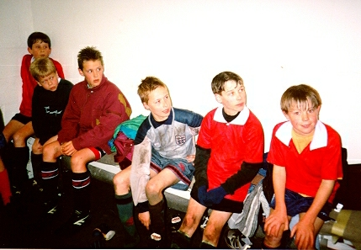

CONGLETON CUB SCOUTS 5-A-SIDE

ST ANDREWS ‘A’: WINNERS 1996

Played at Congleton Leisure Centre Sunday 30th June 1996

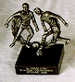
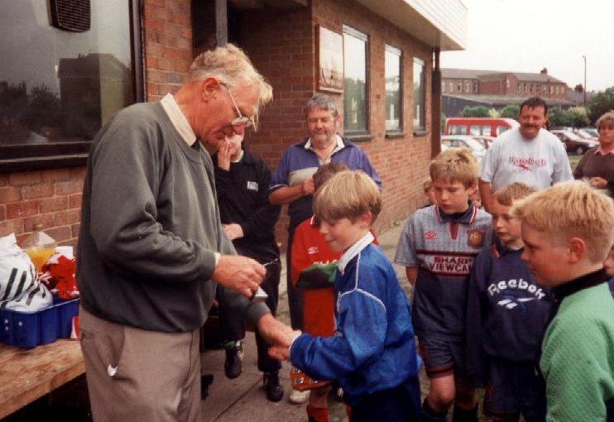

Group A: St Andrews 'A' 5 St Andrews 'B' 1 (3?)
St Andrews 'A' 6 Dane Valley 'B' 0 (2?)
St Andrews 'A' 9 Mossley 9 (5?)

P W D L Pts
St Andrews 'A' 3 3 0 0 6
St Andrews 'B ' 3 2 0 1 4
Dane Valley 'B' 3 1 0 2 2
Mossley 3 0 0 3 0

Semi Final: St Andrews 'A' v Dane Valley 'A'??? (6-1?) (2?)

Final: St Andrews 'A' 3 Congleton Bears 0 (1)

Squad: Alistair Lewis William Morrison
Billy Maddox Darren Addison (F)
James Ferguson Sub: Scott Blackburn

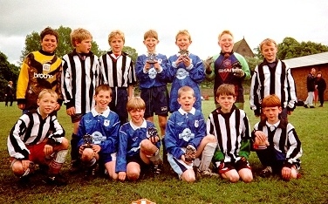
MACC BOYS

Squad Member 1995-96


Robert Swindells Jason Riley Joel McNeil TJ Dolan
Henry Mott Alex Heylings Alan Wright Darren Addison (F)
Ben Davies Peter Shaw Oliver Shaw David Cusick
Simon Gorton James Ferrari Ryan Delargy

Player of the Year 1995-96


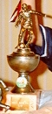

Awarded at Macclesfield Leisure Centre. Presented by Gordon Hill.

Sat 22nd June 1996 (following return from France v Holland, Anfield)
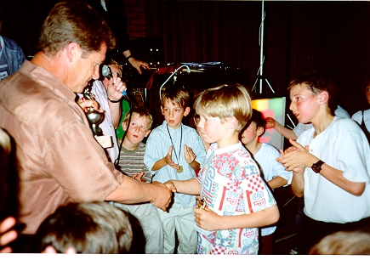

MID-CHESHIRE LEAGUE

Games played Sunday AM Home games played at Bollinbrook Primary School, a couple at Upton Priory School.

League:

Macc Boys 5 Sandbach 1

Moulton 1 Macc Boys 3 (2) …. 1 pen having been brought down.
1 juggle from Gkick & lob over keeper
Macc Boys 3 Edgerton 2

Witton A 4 Macc Boys 2 PM game following appearance at Crewe A with
selectees from Macc Boys & Gordon Hill
Hayes 4 Macc Boys 0 Bad referee

Sandbach 3 Macc Boys 2 (2)..…. 2 free kicks from edge of box

Edgerton 3 Macc Boys 2

Winnington 1 Macc Boys 10 (5) Poor pitch. Match videod.

Macc Boys 2 Witton A 4 ?????
Northwich 4 Macc Boys 2 ?????
Macc Boys 3 Northwhich 3 ?????

Friendlies:

3/8/95 Macc Boys 5 Bollington 8 (3 periods) (5) At Ryles Park

Macc Boys 6 Macc Boys U'8' 5 (only 7 players) (5?) At Beck Lane, Upton

Macc Boys 1 Macc Boys U'8' 0 (Late R Delargy strike) (-) At Bollinbrook

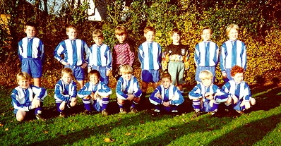
Robert Swindells, Joel McNeil, Nick Johnson, Ben Davies, Alan Wright, James Ferrari, Jason Riley, Ryan Delargy

Oliver Shaw, Peter Shaw, Dan Hutcheson, Darren Addison, TJ Dolan, Tom Braithwaite, Alex Heylings

PARK ROYAL SCHOOL

Some appearances for ‘B’ team.

BOLLINGTON UNITED

SIGNOL FC: 6-A-SIDE

BOLLINGTON UNITED: RUNNERS UP 1996

Played 5 games in Group: Rose Hill Rovers?, Hillgate Boys?
**?

Semi Final: Bollington 0 Signol 0
Bollington won 5-4 on pens (1)…. All Bollington's penalties scored, Daz's off right hand post.

Final: Bollington 0 Mountfield 3

Squad:

Jason Shuttleworth Jack Ainsworth
Nick Johnson Shaun Foster
Darren Addison (F) Chris Holroyd
Jordon Evans Mathew Jackson

COMMENT
Warm sunny day. Bollington ran out of steam in the final after a tense penalty shoot out.


